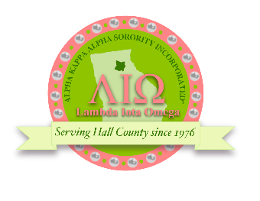

Alpha Kappa Alpha Sorority, Inc. Lambda Iota Omega Chapter
Alphia Wills Scholarship

Lambda Iota Omega’s Alphia Wills Scholarship offers deserving students in the Gainesville- Hall County area financial assistance in attending the college of their choice. A scholarship will be awarded in the amount of $500 for the 2023 -2024 academic school year.
Soror Alphia Wills is a native of Asheville, North Carolina and a graduate of North Carolina Central University, Spanish University, and Brenau University. She was initiated into our esteemed sorority in December of 1963. She is a Charter Member of the Lambda Iota Omega Chapter of Alpha Kappa Alpha Sorority. She is a retired educator and serves on several community service boards and civic organizations such as Hall County Department of Family and Children Services Board of Directors, Gainesville Hall County Black History Society.

Criteria for scholarship recipients:
Must be a high school senior attending a school in Gainesville/Hall County area or a #CAP participant
Must be a minority student
Must attend a 2- or 4-year college in the upcoming school year
At least a 3.0/4.0 Cumulative GPA (Official Transcripts required)
1 letter of recommendation from a teacher, school official, church/community leader Letter of recommendation from a school counselor including the student’s GPA Completed essay (500 words, double spaced, 12 pt. font)
Photo with application
Face-to-face interview for finalists will take place on April 15, 2023, from 9:00AM- 12:00PM
Completed application post marked by April 1, 2023.

Please mail your completed application to:
Alpha Kappa Alpha Sorority, Inc. Lambda Iota Omega Chapter P.O. Box 1802 Gainesville, Ga 30503
School Counselor: Please include the applicant’s GPA (ex: 3.0 out of 4.0) in your recommendation.

Deadline for Applications: April 1, 2023.
We will notify the recipient and counselor by May 1, 2023.

Please note: Scholarships will be awarded to students once college/university/technical school enrollment verification has been received by Lambda Iota Omega.

For questions, please email lioscholarship@gmail.com

Alpha Kappa Alpha Sorority, Inc.
Lambda Iota Omega Chapter
Alphia Wills Scholarship
(Please fill out the form completely)
Full Name:

Mailing Address

City State Zip

Cell Phone:

Email Address:

Birth date:

High School:

School Counselor’s Name and Phone:

INFORMATION ABOUT YOU
Extra-Curricular Activities:

Awards & Achievements:

Your Future Goals:

Essay Question
“Why is it important for young people to serve in their community?”
Please compose an essay explaining why you think that it is important for young people to serve in their community. Your essay should be 500 words, typed, double spaced, and 12 pt. font

